Olustvere School of Service and Rural Economics hosted 8 Spanish students for a meat processing course during the periood of 24.03 – 13.04. 2019
The list of students:
Pulido Sánchez, Adrian Iván
Morente Díaz, Guillermo
Santiago Fernández, Ramón
Galdón Ortiz, Felipe
Gil Molleja, Pedro
Cabrera de los Santos, Nerea
Rodríguez Gómez, Javier
Guerrero Muñoz, Raul
The aim of the course was
- Learn how to cut pig, chicken, lamb, beaver
- Make different kinds of sausage
- Make some local meat dishes
- Learn how to use vegetables in a creative way (Frucktodesign)
- To visit meat processing facilities in Estonia
- Learn about Estonia by visiting Soomaa National Park during the flood season
- To visiting Pärnu

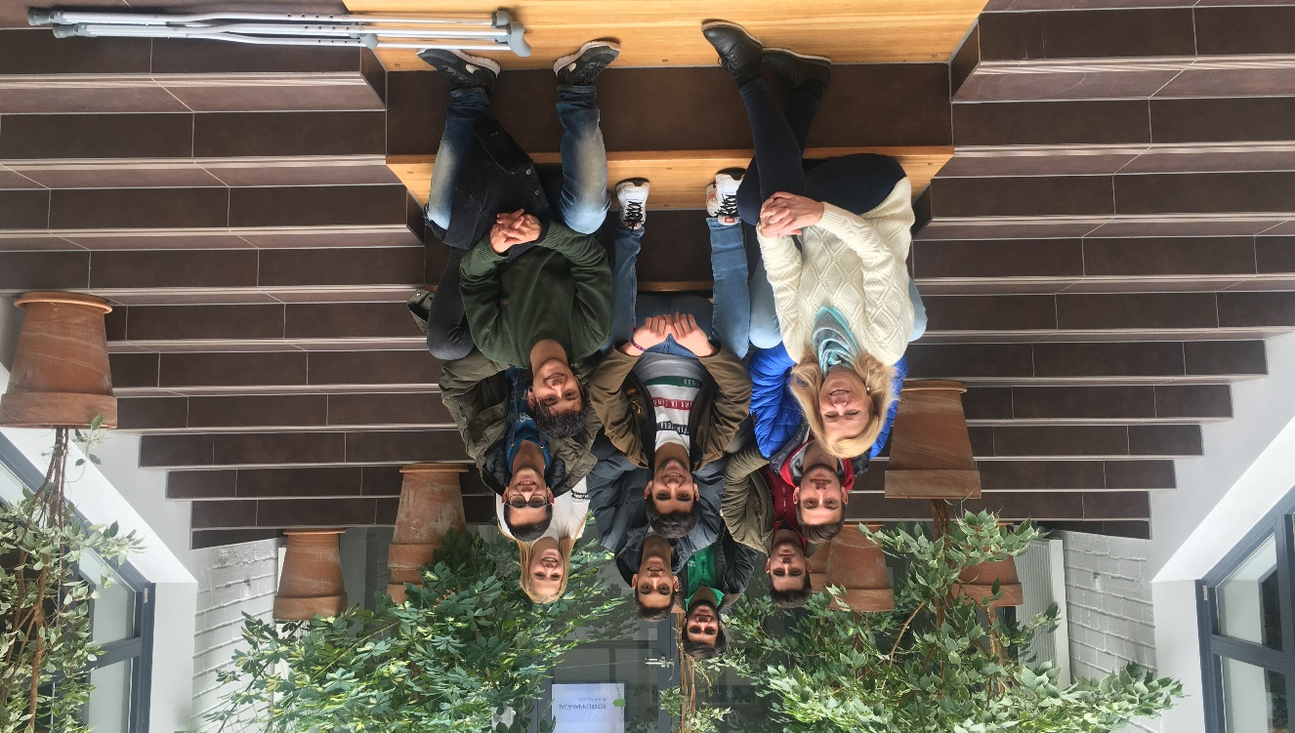

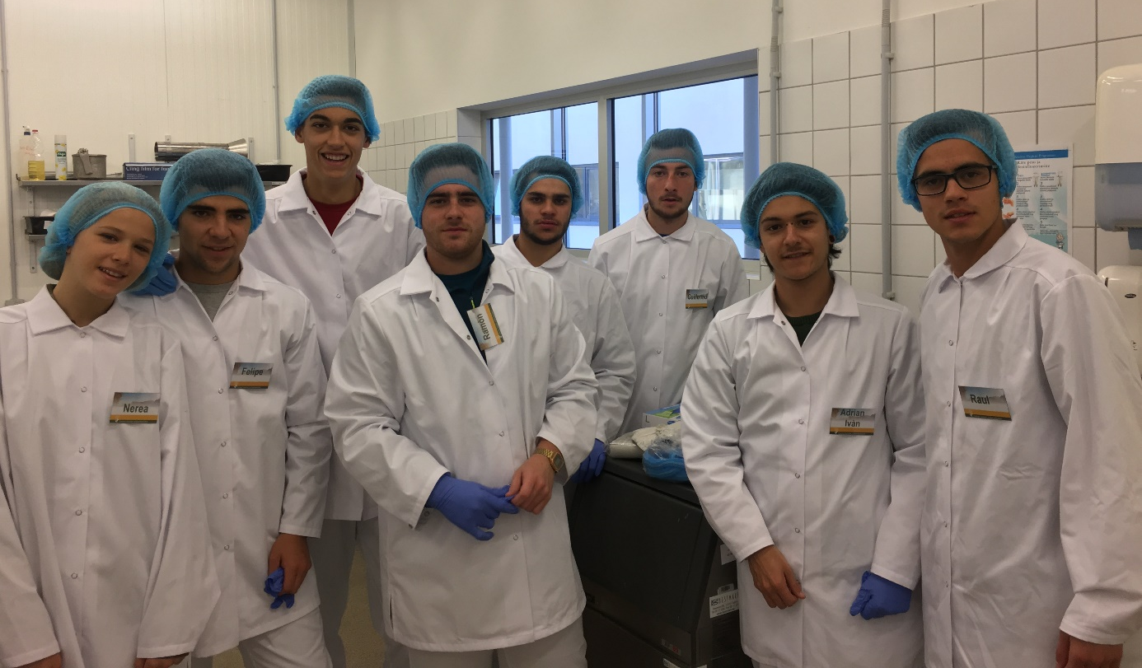
Students in the meat processing facility, ready to start work.

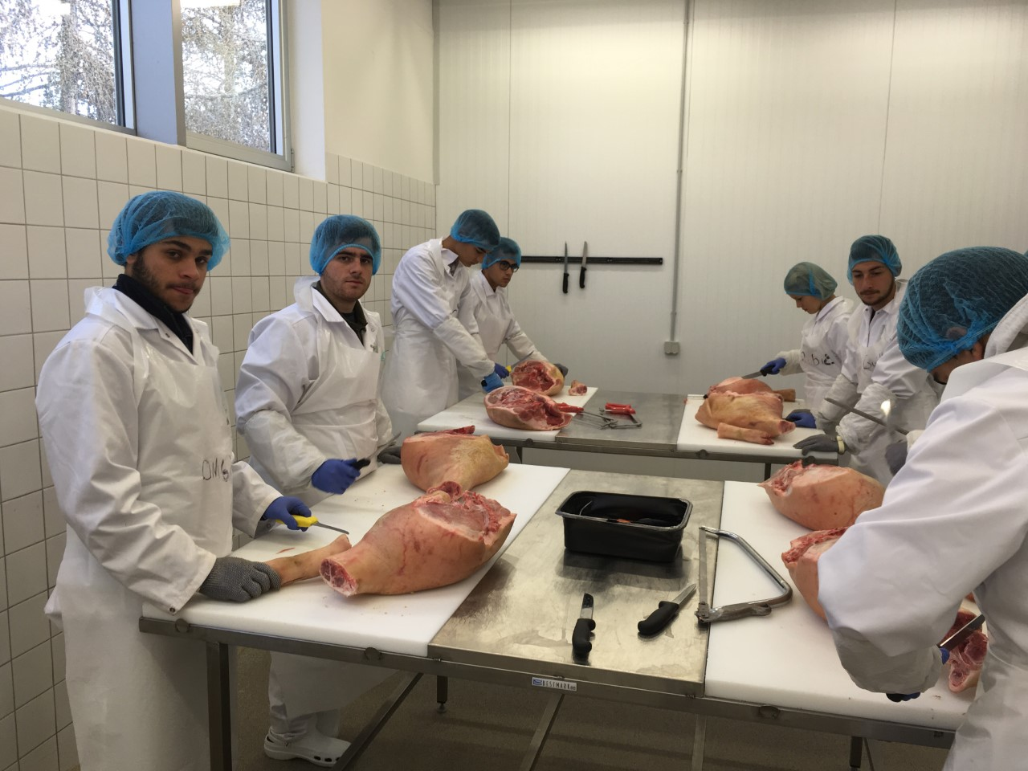
The first job.
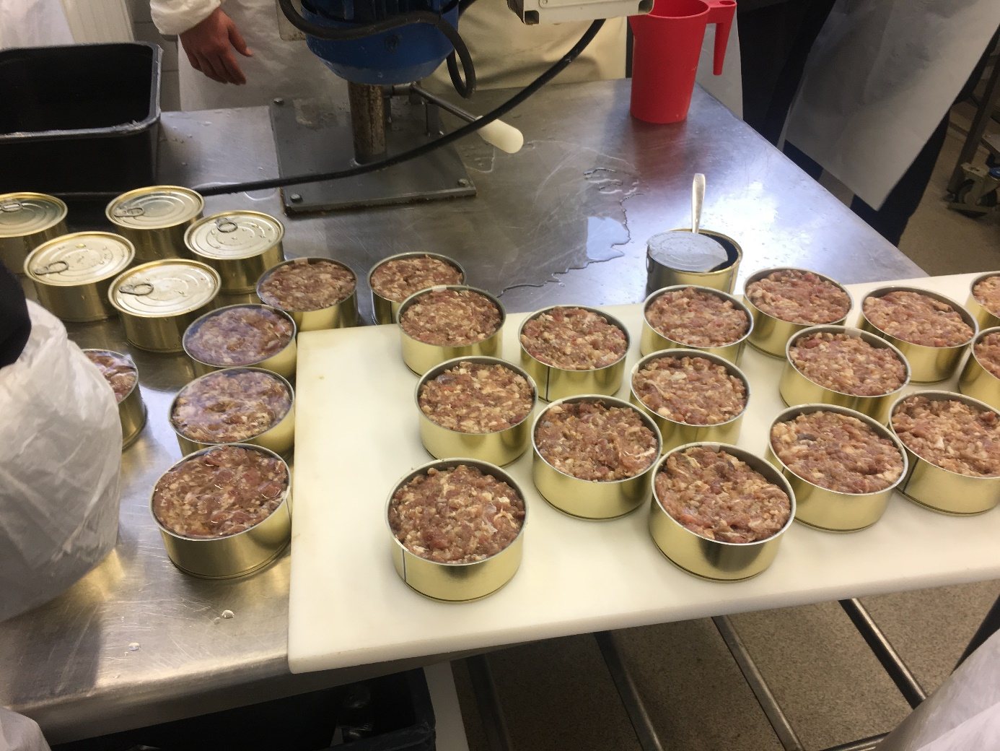
Almost finished product

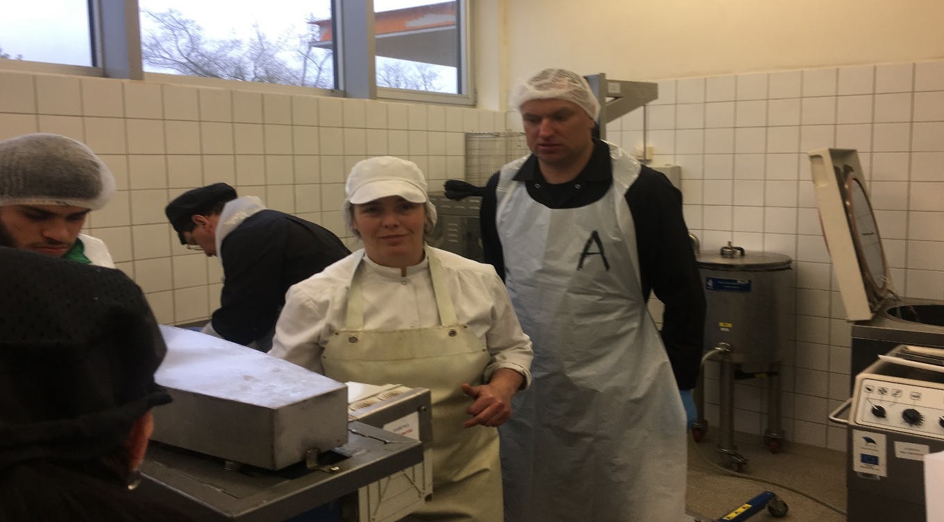
Eve Kletternberg –meat processing teacher

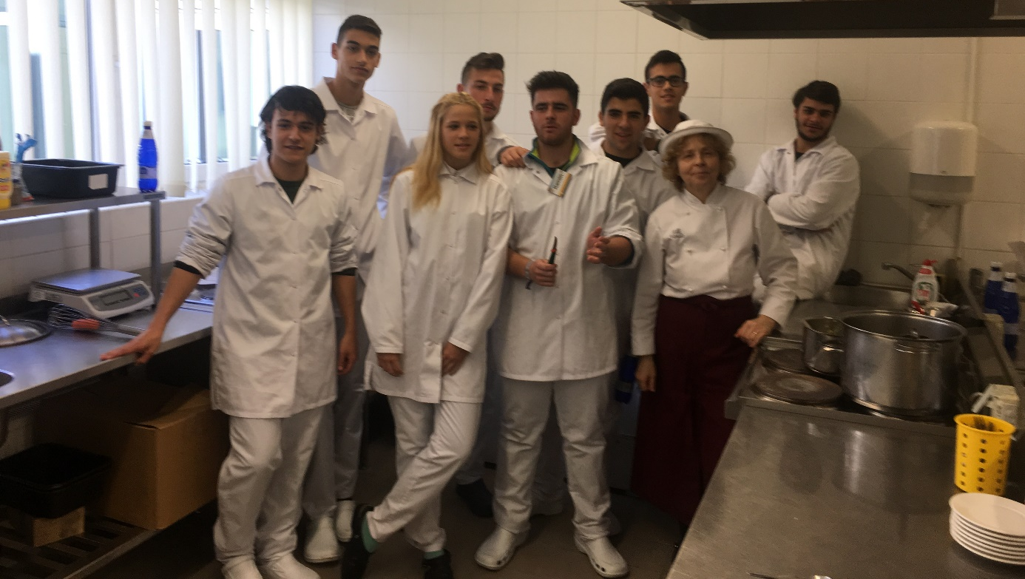
Elli Vendla - cooking teacher in the class

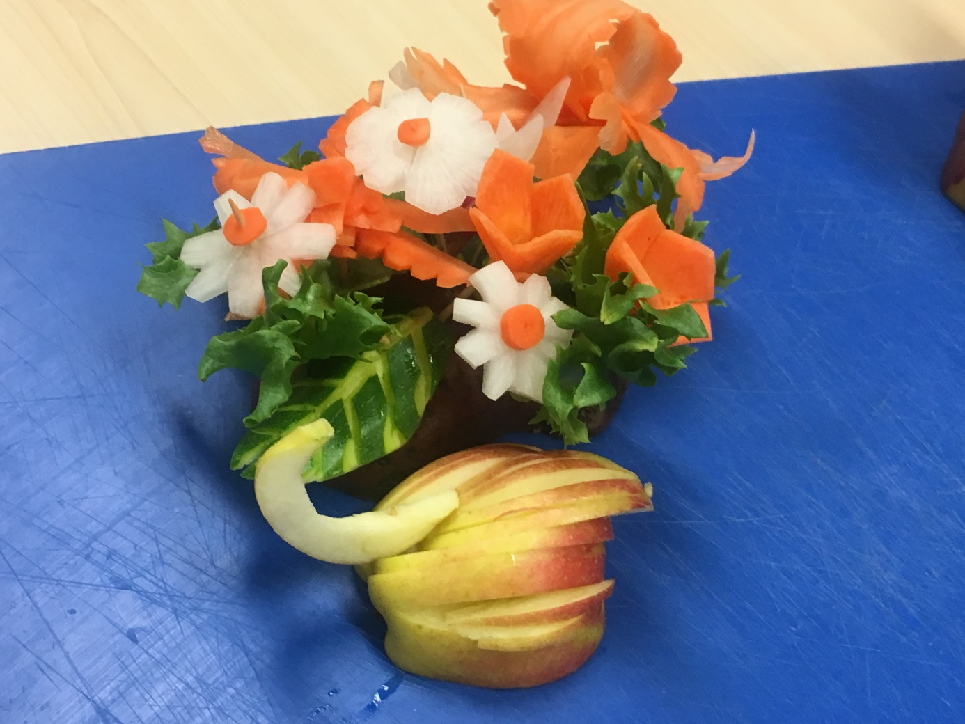
Frucktodesign

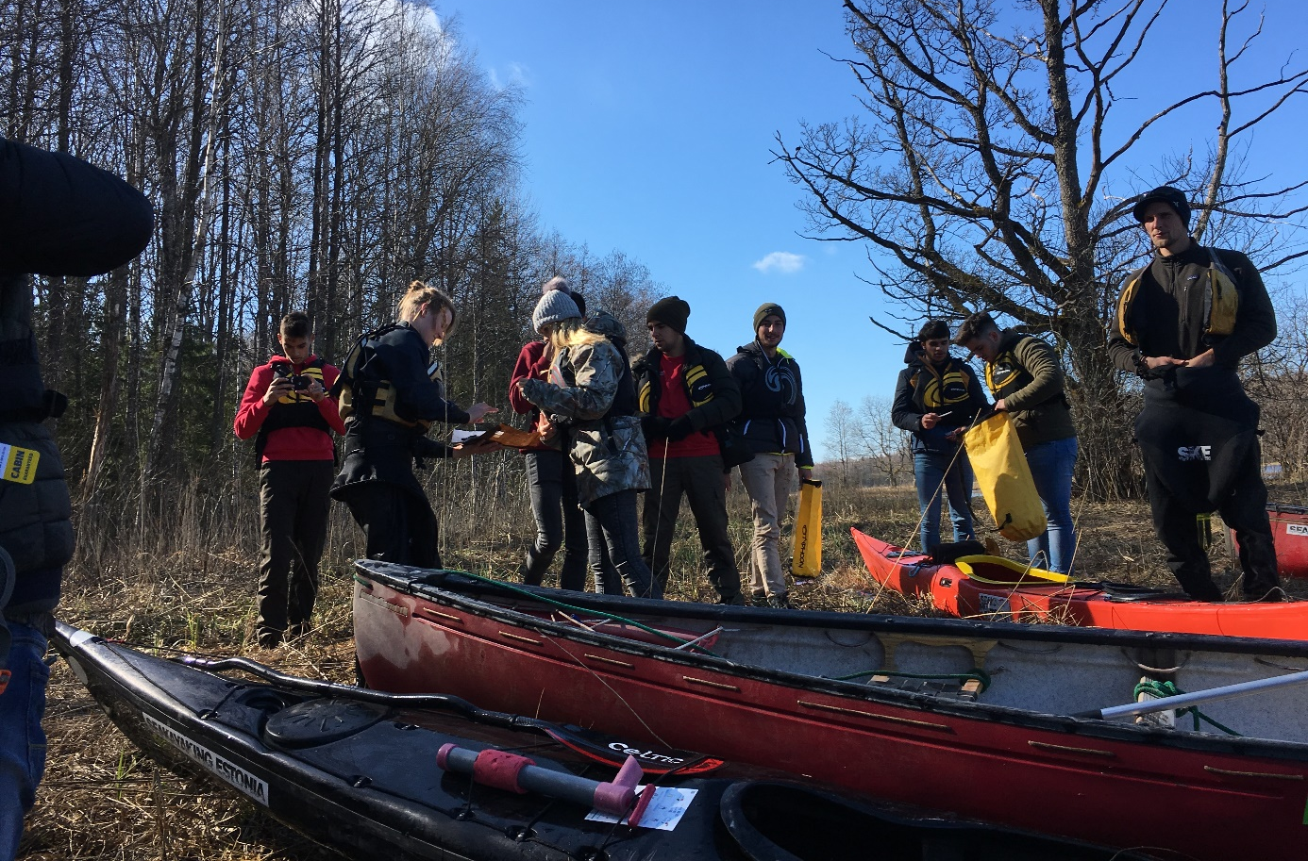
Canoeing in Soomaa National Park

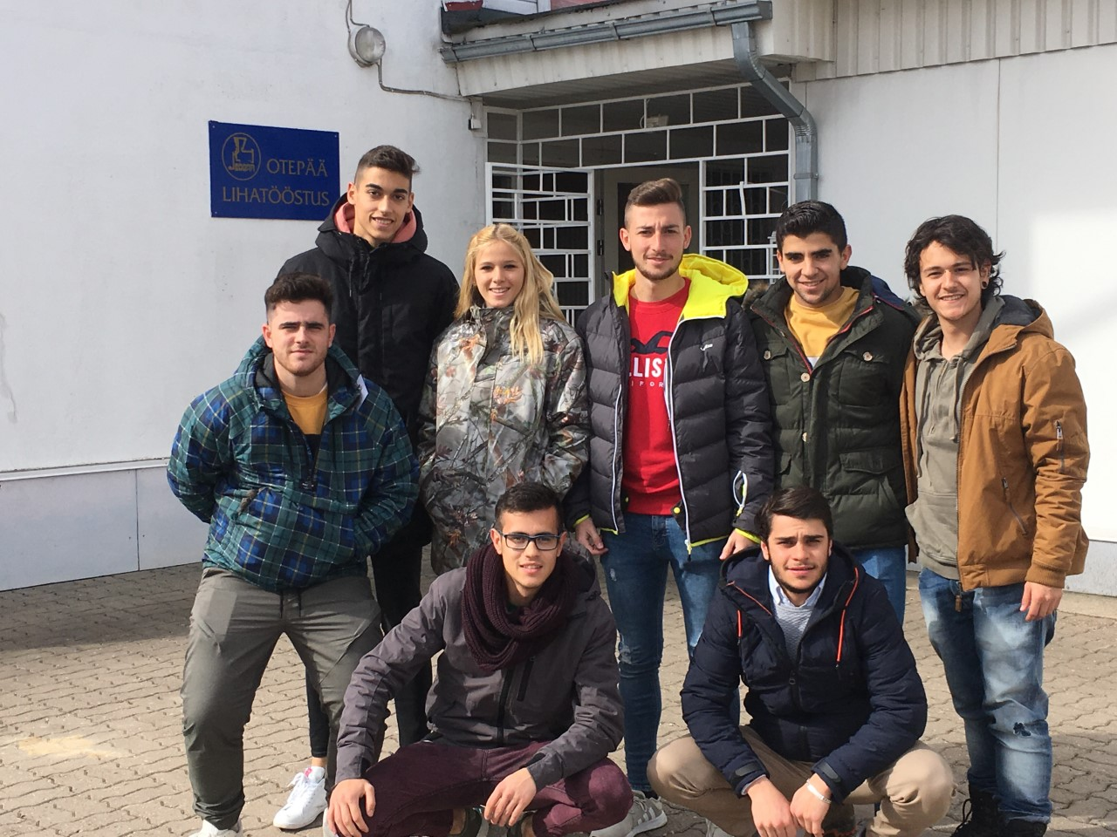

SPANISH STUDENTS BLOGS ON THE MEAT PROCESSING COURSE.
Raúl:
https://raulestonia.blogspot.com/?m=1
Guillermo:
https://myblogofestonia.blogspot.com/?m=1
Ramón:
https://myerasmusexperiencetorete.blogspot.com/
Javier:
https://experienciaenestonia.blogspot.com/?m=1
Pedro:
https://jdkdids.blogspot.com/?m=1
Nerea:
http://andalucesporestonia.blogspot.com/
Felipe: https://www.blogger.com/blogger.g?blogID=6258751711484464742#allposts

